**Forum for Linguistic Studies 2025, 7(2)**

**ISSN:2705-0610 E-ISSN:2705-0602**

# STUDY THE RELATIONSHIP BETWEEN STRESS AND SELF-CONFIDENCE AMONG ADOLESCENT STUDENTS STUDYING IN GOVERNMENT HIGHER SECONDARY SCHOOLS OF DEHRADUN DISTRICT”

**Ms. Seema**

Ph.D. Scholar, Department of Education, SGRR University, Dehradun, Uttarakhand [Email-pandeysimi221@gmail.com](mailto:Email-pandeysimi221@gmail.com)

# Prof. (Dr.) Malvika. S.Kandpal (Research Supervisor)

Dean, Department of Education, SGRR University, Dehradun, Uttarakhand

[**Email-**mskandpal1234@gmail.com](mailto:Email-mskandpal1234@gmail.com)

**Abstract –** The present era is the age of modernity. Humans have made progress in every field. As a result of this progress, changes can be seen in an individual’s personal, professional, and social life. Along with several beneficial outcomes, some harmful effects are also observed. People are struggling with various mental problems, one of which is stress.

According to Hans Selye stress as “the body’s non-specific reaction to any demand made on it.” Stress can be understood as a state in which an individual finds it difficult to manage or control situations. In today’s society, nearly every second person experiences stress. Adolescence is considered one of the most crucial phases of human life. Many recent researches indicate that stress influences various aspects of human being’s life, including physical and mental health, social behaviour, self-confidence, and more.

In the present research paper, a study has been conducted on the relationship between stress and self-confidence among adolescent students. A sample of 100 adolescent students were selected for the study. To measure the variable of stress among adolescents, a scale developed and standardized by Dr. Jaki Akhtar was used. For the study of self-confidence among adolescents, a scale developed and standardized by Dr. Madhu Gupta and Vindhya Lakhani was used. For the analysis of data, statistical methods such as Mean, Standard Deviation and Karl Pearson’s product moment correlation were used.

# Keywords – Higher Secondary, Adolescents, Adolescence, Stress, Self-confidence, Correlation.

**Introduction –**Adolescence is an important stage of human development marked by major physical, emotional, and psychological changes. At this time, adolescents encounter several challenges and stress factors, including academic demands, social interactions, and the search for identity. These stressors can greatly influence their overall growth and well-being.

At the same time, self-confidence or self-efficacy is crucial in enabling adolescents to deal with various challenges. It impacts their academic achievements, social relationships, and emotional strength. Exploring the connection between stress and self-confidence during adolescence is important for creating effective interventions and support systems that can improve their coping skills and overall psychological well-being. At present, stress has primarily affected adolescents. Various scholars have classified the stages of human life development in different ways. Psychologists have categorized the stages of human development differently; however,

they are generally divided into infancy, childhood, adolescence, and adulthood. Each of these stages involves distinct aspects of physical, cognitive, and psychosocial development.

**Infancy (0–2 years):** At this stage, children explore and make sense of the world primarily through sensory experience and physical actions.

**Childhood (2–12 years):** During this period, children develop symbolic thinking, social skills, and moral understanding.

**Adolescence (13–19 years):** This stage is characterized by physical, emotional, and social changes, along with the development of identity and a sense of independence.

**Adulthood:** This stage can be further divided into early, middle, and late adulthood. Individuals in this phase are engaged in careers, relationships, and social roles.

Among these stages, adolescence is considered an extremely important period as it involves numerous changes. **According to Kulhan**, “Adolescence is a period of transition between childhood and adulthood. This stage holds special significance in human development and typically spans the ages of 13 to 19 years; hence, it is also called the ‘teenage period’.”

For adolescent students, having qualities like self-confidence is essential. It would be fair to say that self-confidence is the key to success. “An individual’s abilities and skills, along with their capacity to deal with various situations, constitute self-confidence.” Therefore, self- confidence is highly necessary for adolescents.

In the present time, adolescents frequently experience internal conflicts and struggle to make appropriate decisions. Without proper guidance, they often make poor choices, which eventually lowers their self-confidence. Today’s children are dealing with a variety of challenges. This research paper aims to examine the connection between stress and self- confidence, explore ways to reduce stress, and suggest methods for fostering qualities such as self-confidence.

The objective of this study is to explore the correlation between stress and self-confidence among adolescents. By examining how these two factors interact, we can gain insights into how stress influences self-confidence and vice versa. This knowledge can inform teachers, parents, and mental health professionals in their efforts to support adolescents during this transformative stage, ultimately promoting healthier developmental outcomes.

**Objectives of the Study –**

1. To study the significant relationship between stress and self-confidence among adolescent students studying in government higher schools od Dehradun district.
2. To study the significant relationship between stress and self confidence among adolescent boys studying in government higher secondary schools of Dehradun district.
3. To study the significant relationship between stress and self confidence among adolescent girls studying in government higher secondary schools of Dehradun district.

# Hypotheses –

1. There is no significant relationship between stress and self-confidence among adolescent (boys and girls) students studying in government higher secondary schools of Dehradun district.
2. There is no significant relationship between stress and self-confidence among adolescent boys studying in government higher secondary schools of Dehradun district.
3. There is no significant relationship between stress and self-confidence among adolescent girls studying in government higher secondary schools of Dehradun district.

# Delimitations of the Study –

* + The study is limited to the Uttarakhand state.
  + The study is limited to the Dehradun district of Uttarakhand state.
  + The study is limited to the Raipur Block of Dehradun district.
  + The study is limited to Government higher secondary schools of Raipur block in Dehradun district.
  + The present study includes 100 students (50 boys and 50 girls) in sample from government higher secondary schools of Raipur block.

# Research Procedure –

The present research falls under descriptive research and has been conducted using the survey method. A sample of 100 adolescent students (50 boys and 50 girls) from government higher secondary schools of Raipur block, Dehradun district of Uttarakhand were selected through using the cluster, stratified, and systematic random sampling methods.

# Tools –

* + To measure the variable of stress among adolescents, a standardized scale developed by Dr. Zaki Akhtar was used.
  + To study the variable of self-confidence among adolescents, a standardized scale developed by Dr. Madhu Gupta and Vindhya Lakhani was used.

# Analysis and interpretation of the Data:

**Hypothesis 1:** “There is no significant relationship between stress and self-confidence among adolescent (boys and girls) students studying in government higher secondary schools of Dehradun district.”

# Table-1 - significant Relationship between stress and self-confidence among adolescent (boys and girls) students studying in government higher secondary schools of Dehradun district.”

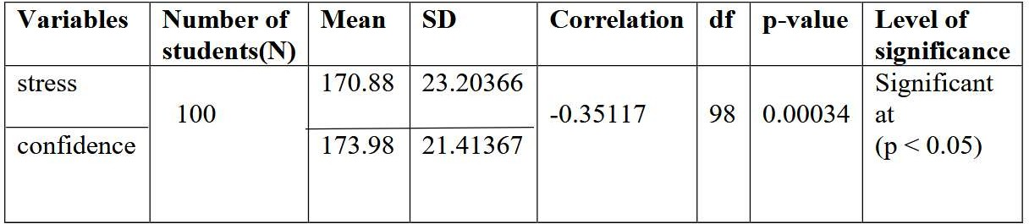

The correlation coefficient (r= -0.35117) shows a negative relationship between stress and self

-confidence. The obtained p-value (0.00034) is less than 0.05, indicating that the correlation is statistically significant. As the p value is below 0.05, the null hypothesis **“there is no significant relationship between stress and self confidence among adolescent students in government higher secondary schools of Dehradun district”** is **rejected.** It is concluded that

there is a significant negative relationship between stress and self-confidence among adolescent students studying in government higher secondary schools of Dehradun district. As stress increases, the level of self-confidence tends to decrease.

# Hypothesis 2:

“There is no significant relationship between stress and self-confidence among adolescent boys studying in government higher secondary schools of Dehradun district.”

# Table-2: Relationship between stress and self-confidence among adolescent boys studying in government higher secondary schools of Dehradun district.”

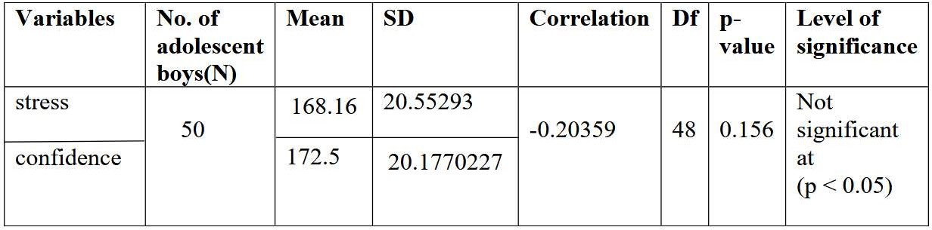

The correlation (r = –0.20359) indicated slight negative correlation, suggesting that as stress increases, self-confidence tends to decrease marginally. p-value 0.156 > 0.05, the result is not statistically significant. The **null hypothesis “There is no significant relationship between stress and self-confidence among adolescent boys** “is **accepted.** There is no significant relationship between stress and self-confidence among adolescent boys in government higher secondary schools of Dehradun district. Although the correlation is slightly negative (as stress increases, self-confidence tends to decrease), this relationship is not strong enough to be considered significant.

# Hypothesis 3:

“There is no significant relationship between stress and self-confidence among adolescent girls studying in government higher secondary schools of Dehradun district.”

# Table-3: Relationship between stress and self-confidence among adolescent girls studying in government higher secondary schools of Dehradun district.”

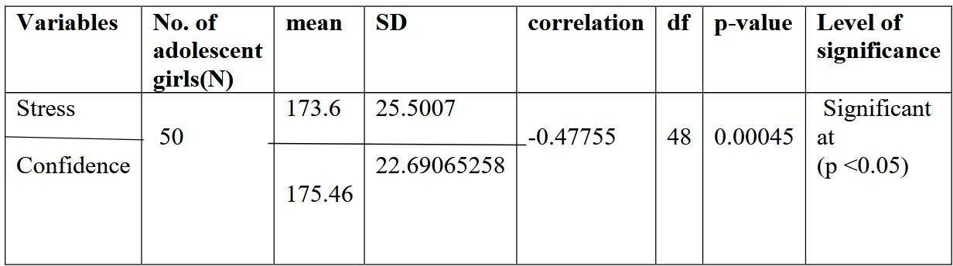

The correlation (r=−0.47755) indicates a negative relationship between stress and self- confidence. The calculated p-value (0.00045) is less than 0.05, which means the correlation is statistically significant. Since the p-value is less than 0.05, **the null hypothesis (H₀) stating "There is no significant relationship between stress and self-confidence among adolescent girls studying in government higher secondary schools of Dehradun district**" is **rejected.**

# Conclusion –

**Hypothesis 1:** The analysis shows a significant negative correlation between stress and self- confidence among adolescent students (boys and girls) studying in government higher secondary schools of Dehradun district. As the p value (0.00034) is lower than the 0.05 significance level, the null hypothesis is **rejected.**

This indicates that as stress levels increase, self-confidence tends to decrease in adolescents. Therefore, efforts should be made to manage stress among students to help maintain or improve their self-confidence and overall psychological well-being.

**Hypothesis 2**: The p-value is greater than (0.156) 0.05, the correlation is not statistically significant. Therefore, the null hypothesis (H₀) stating that “There is no significant relationship between stress and self-confidence among adolescent boys studying in government higher secondary schools of Dehradun district” **accepts.**

It is concluded that although a slight negative relationship exists between stress and self- confidence, this relationship is not statistically significant. Thus, variations in stress levels do not significantly affect the self-confidence of adolescent boys in the studied sample.

**Hypothesis 3:** The analysis shows a significant negative correlation between stress and self- confidence among adolescent girls studying in government higher secondary schools of Dehradun district. As the p value (0.00045) is lower than the 0.05 significance level, the null hypothesis is **rejected.**

The present study investigated the relationship between stress and self-confidence among adolescent students (boys and girls) studying in government higher secondary schools of Dehradun district. The findings revealed that for the overall sample and adolescent girls, there exists a statistically significant negative correlation between stress and self-confidence (Hypotheses 1 and 3). This indicates that as stress levels increase, self-confidence tends to decrease. However, for adolescent boys, the relationship was found to be statistically insignificant (Hypothesis 2), suggesting that variations in stress levels do not significantly influence their self-confidence.

# Suggestions –

Since the study revealed a significant negative relationship between stress and self-confidence among adolescent students (Hypotheses 1 and 3), it is essential to organize regular stress management programs in schools. Activities such as yoga, meditation, breathing exercises, and mindfulness practices should be incorporated into the school routine to help students cope with academic and personal stress effectively

The results indicate that stress significantly affects the self-confidence of adolescent girls (Hypothesis 3), whereas for boys (Hypothesis 2), the relationship was found to be statistically insignificant. This highlights the need for gender-sensitive interventions. Special counselling and mentorship sessions should be conducted for adolescent girls to enhance their self- confidence and resilience.

Teachers and parents play a vital role in shaping adolescents’ mental well-being. Training programs and workshops should be organized to sensitize teachers and parents about the symptoms of stress in adolescents and equip them with strategies to provide emotional and academic support. A positive and encouraging classroom environment can help in reducing stress levels among students.

Schools should include life skills education as part of the curriculum. Training in time management, problem-solving, decision-making, and emotional regulation will help students manage stress more effectively while improving their confidence in handling academic and personal challenges.

Schools should establish collaborations with counsellors, psychologists, and mental health experts to provide confidential counselling services.

Participation in sports, cultural programs, and creative activities should be encouraged to provide students with opportunities for relaxation and self-expression. Such activities can act as a buffer against stress and help in building confidence and a positive outlook.

**References:**

Singh, A. K. (2006). Ucchatar samanya manovigyan (p. 754). Motilal Banarsidass. ISBN 81- 208-2081-9 (hardcover); ISBN 81-208-2082-7 (paperback).

Bhatnagar, S. (2008). Shiksha manovigyan tatha shikshan shastra (p. 267). Vinod Pustak Mandir. ISBN 81-7457-314-3.

Porwal, K., & Kumar, R. (2014). A study of academic stress among senior secondary level students. The International Journal of Indian Psychology, 1(3), 133–137. https://[www.ijip.in](http://www.ijip.in/) Hachintu, M., & Kasisi, F. (2022). The effect of stress on the academic performance of high school students in Lusaka. Journal of Psychology and Psychotherapy, 12(S7), 005. https://doi.org/10.35248/2161-0487-22.S7.005

Wali, K. M. (2024). Stress among university students. International Journal of Multidisciplinary Research (IJFMR), 6(2), 1–7. https://[www.researchgate.net](http://www.researchgate.net/)

Pilkhwal, S. (2023, February). A comparative study of self-confidence levels of boys and girls studying at the secondary level in the context of their personal background. Journal of Social Review and Development, 2(1), 21–24.

https://link.springer.com [http://shodhganga.inflibnet.ac.in](http://shodhganga.inflibnet.ac.in/)